**SJA website - Final Corrections**

**Home**

1. ‘See the unseen’ in bold
2. Recognitions to Awards

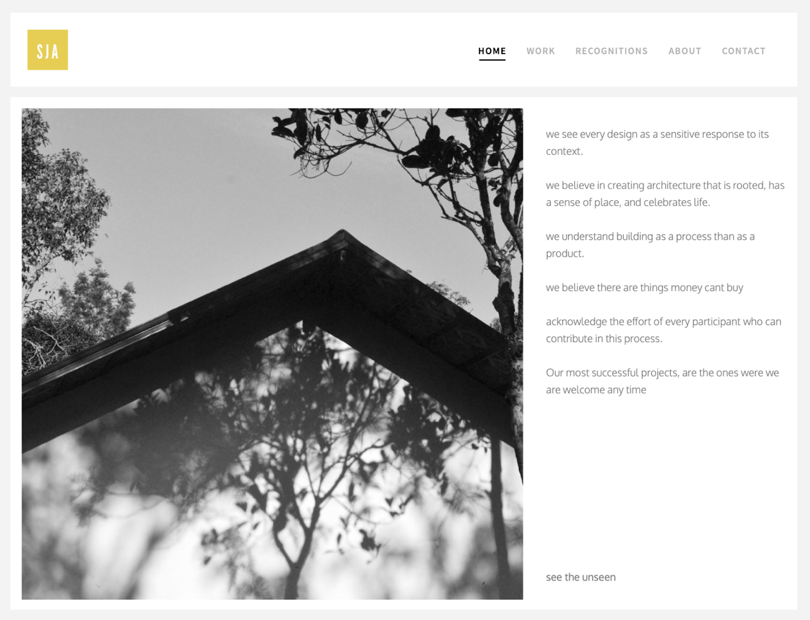

**Works**

1. Offset on all four sides (blank white space) *1
2. Thumbnails should be in square proportion

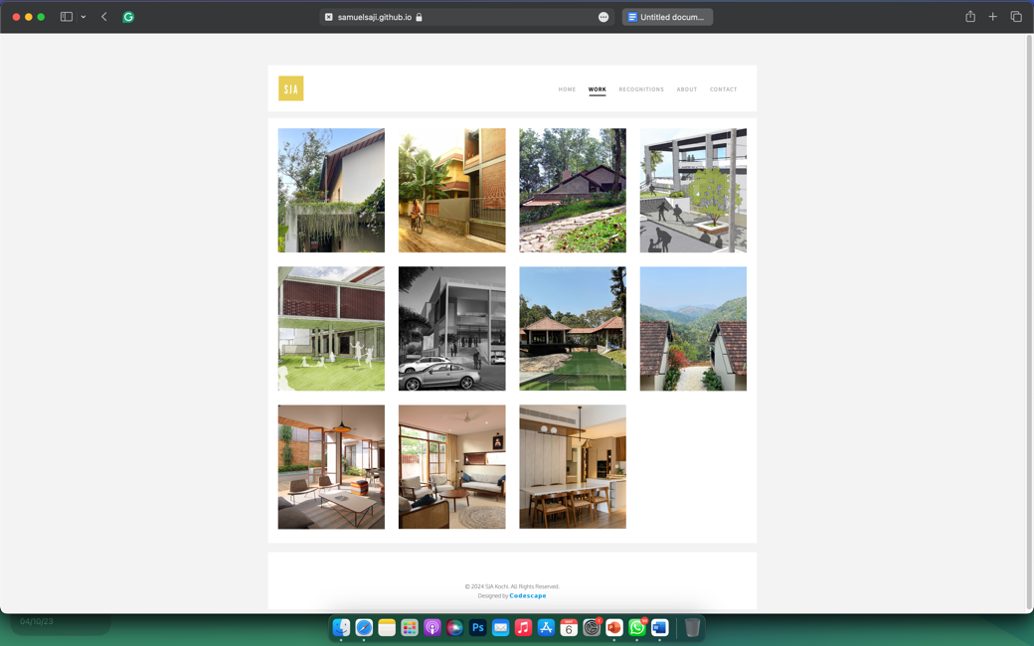 existing

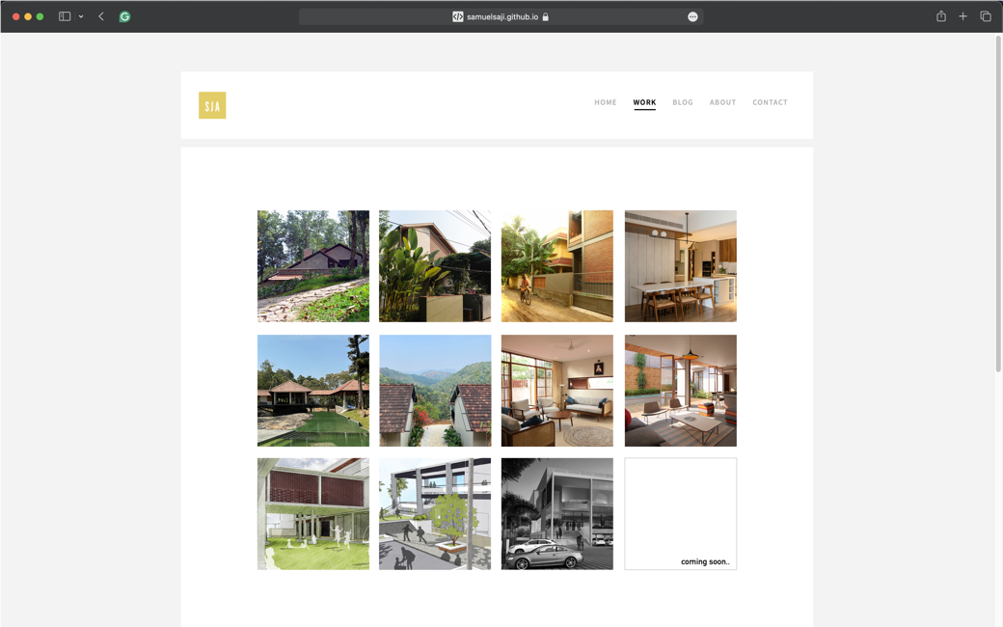 correct order of projects

*1

1. **Order & Thumbnail hover info**

Stone House Munnar – Holiday Home

Vimal - Lakshmi – Residence

Sariga - Arun – Residence

Paul Mathew - Residence

Munnar Resorts – Hospitality

Dreams on Leaves – Hospitality

Nameh – Residence

Pranoy – Residence

Lost school Aluva – Institution

St. Thomas Auditorium – Public/Institution

Convention Centre – Public

1. Shape of ‘back icon’ to follow the character of the ‘go up’ icon

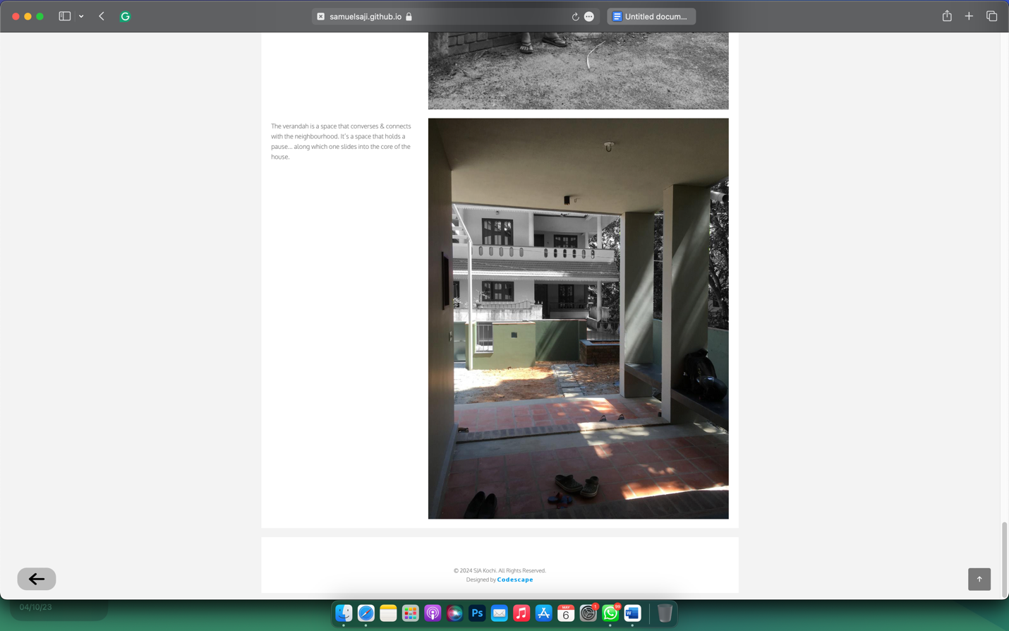

**Awards**

1. Correction in the titles of banner images (updated images shared in whatsapp)
2. Remove vignette at edges

**About**

1. Correct font style of follow up page (Jills sir and Soumya maam) to match with the rest of the pages

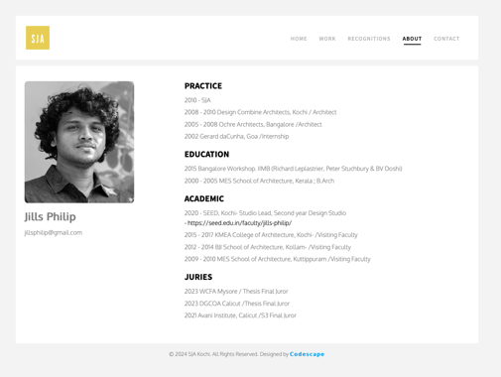

1. Add follow up page for Alumini
2. Reduce font size of images to that of ‘About Us’

